|  |  |  |
| --- | --- | --- |
|  |  | **School Newsletter 16th October 2023 2023** |
| **Ltyentye Apurte Catholic School**  Church Street, Santa Teresa, PMB 221, Via Alice Springs, NT, 0872.  Telephone: (08) 8956 0937 email: robert.dreise@nt.catholic.edu.au |

Dear Families,

**Arrernte Language & Culture Teaching Team and Literature Production Centre**

Ltyentye Apurte Catholic School (LACS) continues to take steps towards strengthening the Arrernte Language and Culture program. We welcome Marcus Williams to the Arrernte Language and Culture Team. A timetable has been developed which will help increase Arrernte teaching time, facilitate collaboration on program writing, embed bush trips, develop resources, design assessment tasks and work with the teacher-linguist, to build a carefully sequenced and detailed program across all classes in the school. A new Language and Culture Hub is being established which will feature indoor teaching spaces, outdoor learning areas, cooking areas, outdoor fire pit, Aboriginal murals, and a yarning circle.

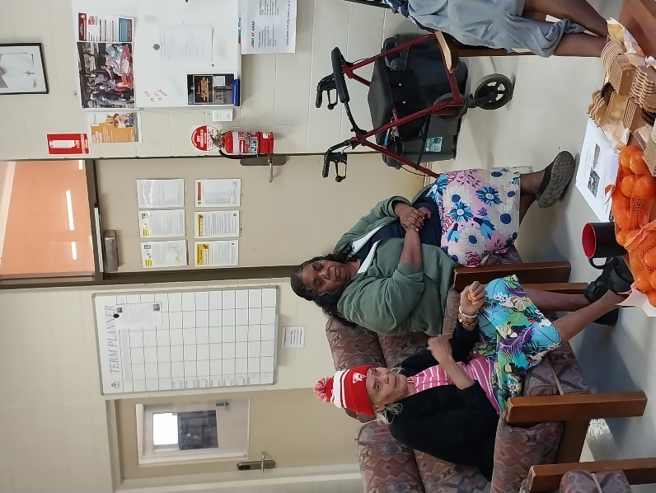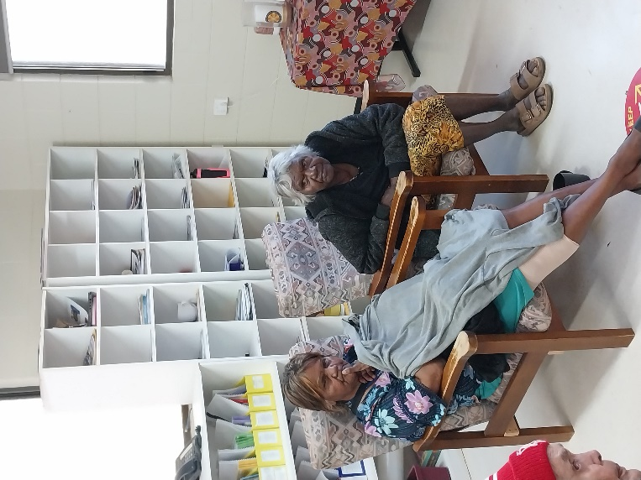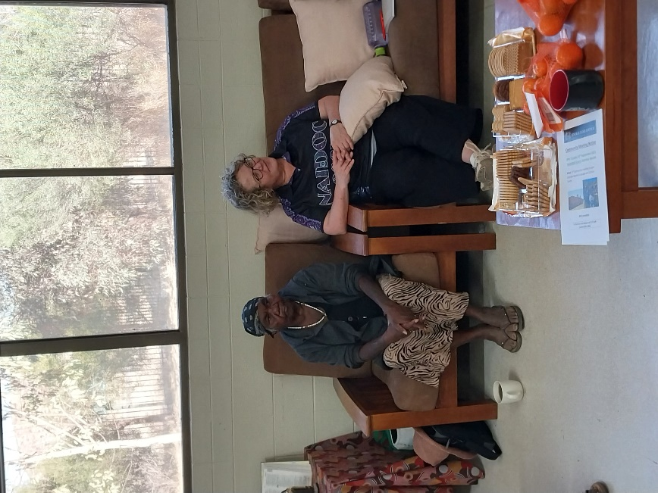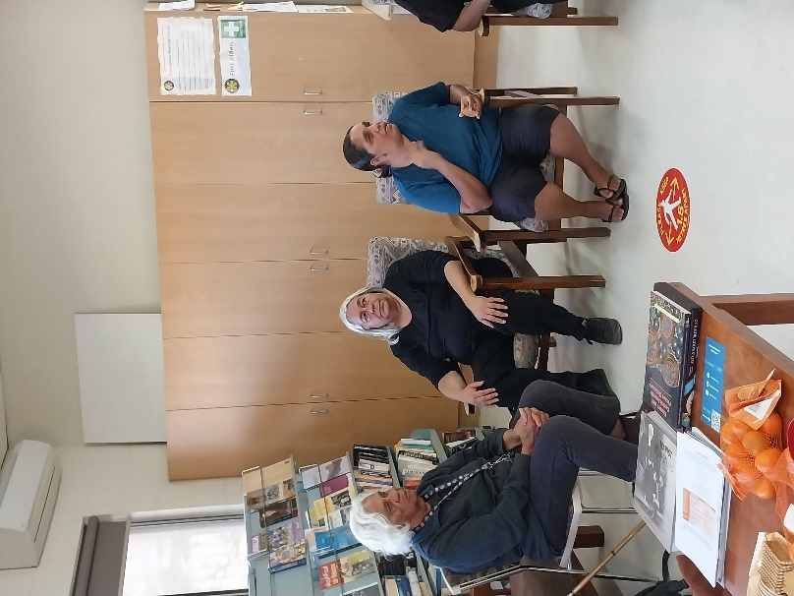

Meeting with elders to discuss our Language and Culture Centre plans.

|  |  |
| --- | --- |
| The Arrernte Language & Culture Teaching Team and the Literature Production Centre (LPC) Team both reports directly to the **Principal** and **Catholic Aboriginal Leadership Team (CALT)** | |
| **Arrernte Language & Culture Teaching Team**   * Teacher Linguist: Carol Muir * Three Arrernte teachers: * Julia Cavanagh: * Marcus Williams: * Carmel Ryan: * Assistant Teachers in each class * Dr Susan Poetsch Indigenous Languages * Learning on Country Coordinator | **Literature Production Centre (LPC) Team**   * LPC Manager/Coordinator * Aboriginal Literacy Workers (creating stories & books) * LPC Production Workers (creating educational resources) * Language specialist/s (casual) * LPC Artist (casual) * LPC Graphic Designer |

**Other News**

|  |  |
| --- | --- |
|  | **Rest in Peace Gavin Breer**  Our deepest condolences to the family of Gavin Breer. Gavin collected material on 49 Aboriginal languages of Central Australia. He was the architect of modern Eastern and Central Arrernte orthography and had a close association with several members of our school community. Staff will represent our school at his funeral service this week. |
|  | **Rest in Peace Sr Robyn Reynolds** Sister Robyn was an extraordinarily loving person of deep sensitivity and compassion. May her beautiful soul Rest in Peace. |
|  | **Welcome**  A warm welcome to the following staff. Larissa is the new J2 teacher. Sharon will teach M1 to allow Marcus to join the Arrernte Language and Culture Teaching team and Clay is our new cleaner. They have made an immediate impact, and each bring skills and talents that will be very beneficial to the students at LACS. We are very lucky to have such talented staff join our school community. |
|  | Sport and Well-Being Program  Blak Doll Sport and Fitness Mob are delivering a 10-week program designed to help young people manage their mental health and improve their general wellbeing. The program sees current and former elite athletes deliver programs about how to keep physically and mentally fit. We welcome Vanessa and her team. |
| **Staff Cultural Awareness Day** | Recently, Arrernte staff organised a Cultural Awareness Day for visiting staff. We were taken on country to learn about bush foods, bush medicine and finding water. We were joined by Paul Greaves, Director of Catholic Education NT. (see photos) |
| [This Photo](https://www.wisc-online.com/asset-repository/viewasset?id=1276) by Unknown Author is licensed under [CC BY-NC](https://creativecommons.org/licenses/by-nc/3.0/) | **Monday October 16th**  Marist Solidarity Retreat Community Visit  **Tuesday October 17th**  Post Referendum para-liturgy 11:30am in the library  Blue Earth Games Visit  **Wednesday October 18th**  Swimming Lessons Commence  Sport and Well-being Program |

Our thoughts and prayers are with our friend and colleague Julia during this sad time as she deals with the loss of her beloved husband.

Eternal rest grant unto them, O Lord, and let perpetual light shine upon them. May the souls of the faithful departed, through the mercy of God, rest in peace. Amen.



Mr. D

A / Principal

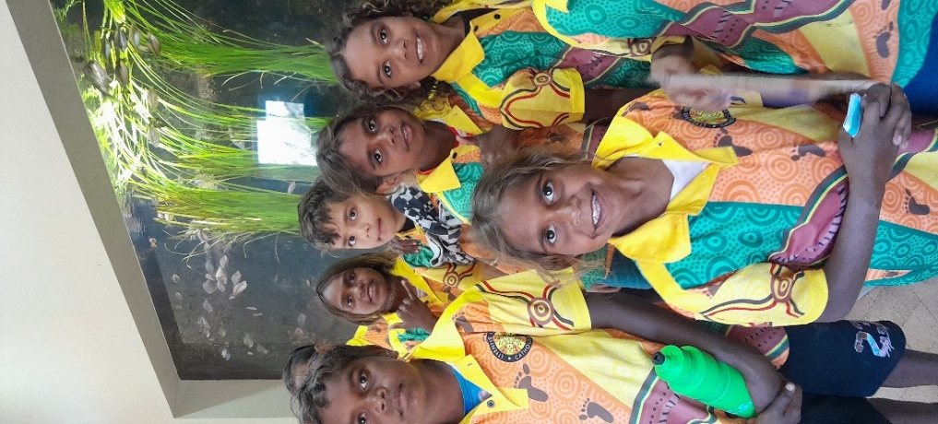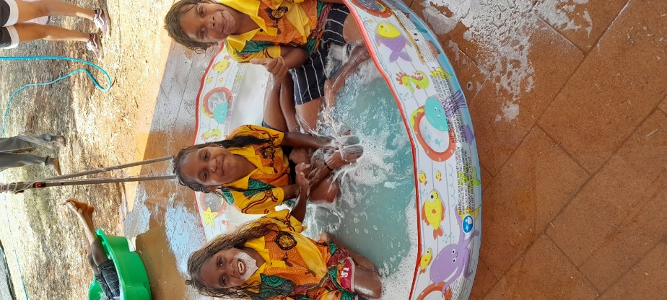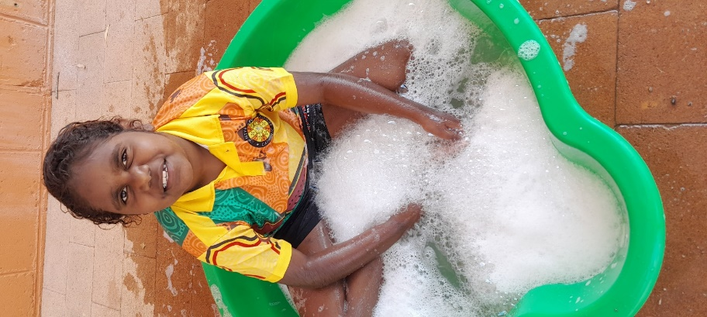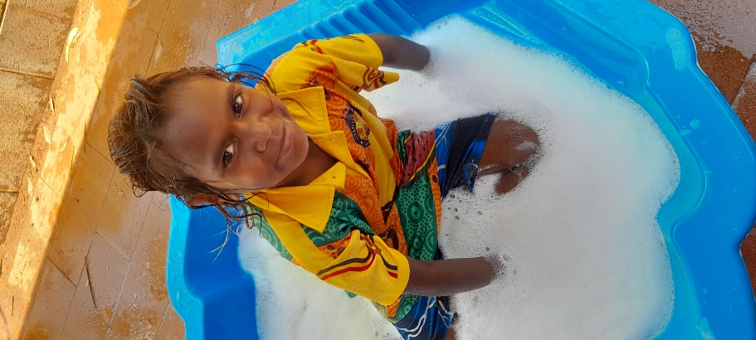

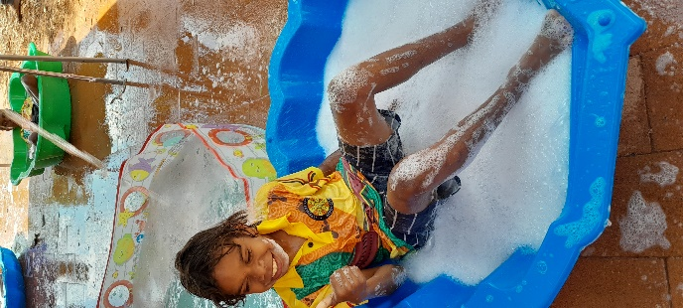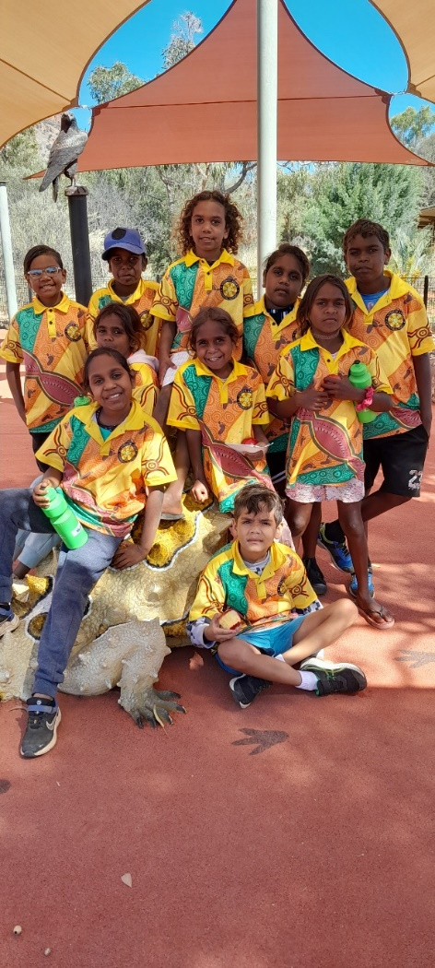

Water Play Day

Day

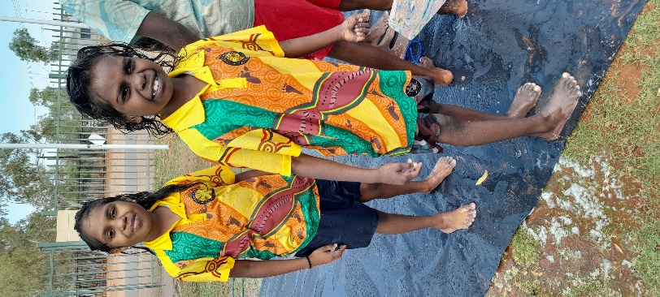

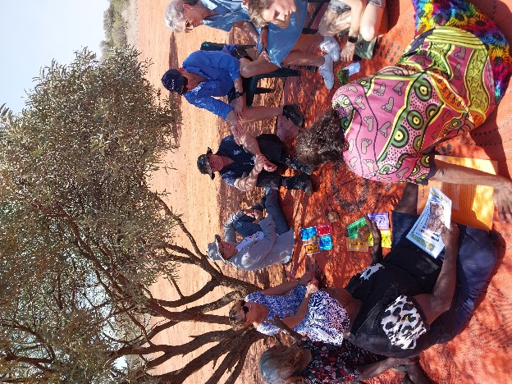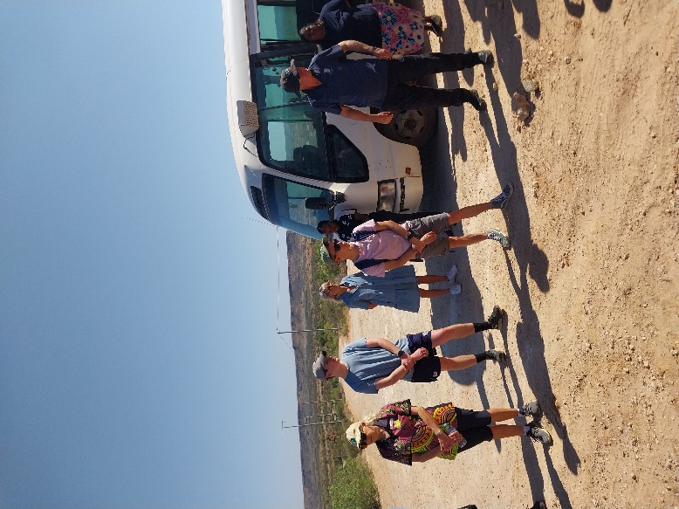

Staff Cultural Awareness Day

